**Unity Games**

**Rider**

Let’s start with making rider game

* Character -> Small Car
* Perfectly land on platform
* Make different kind of surfaces
* Make a collider
* Will set neon on the lines/platform
* Camera & car controllers
* Add bunch of fancy stuff also

<https://www.youtube.com/watch?v=9Ztd1XXmUGI&t=18s>

**Journey Begins Now**

Let’s start to develop rider game

1. Create a new project: File -> new project

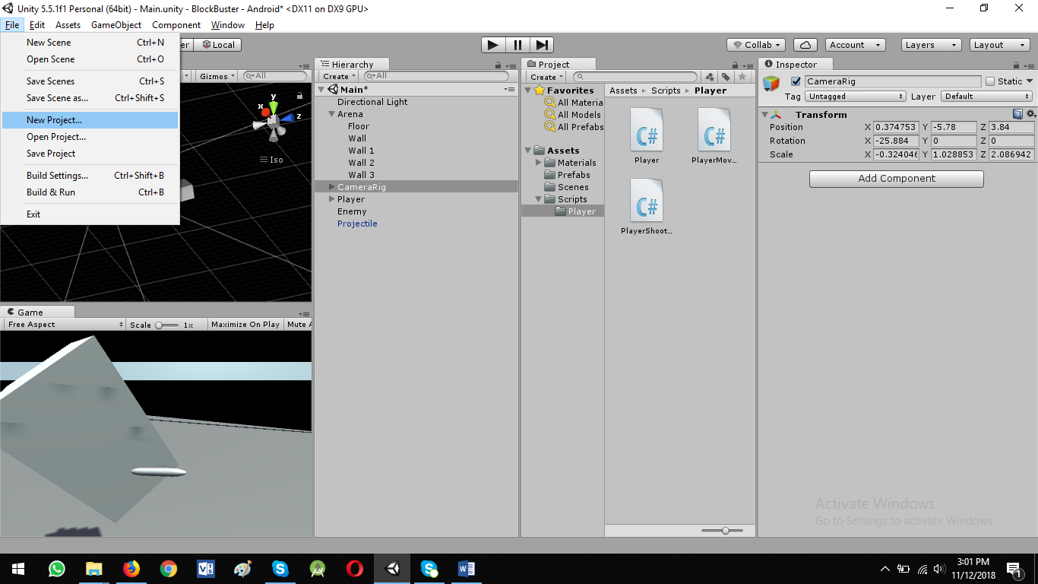

**Name: Rider**

Select option: 2D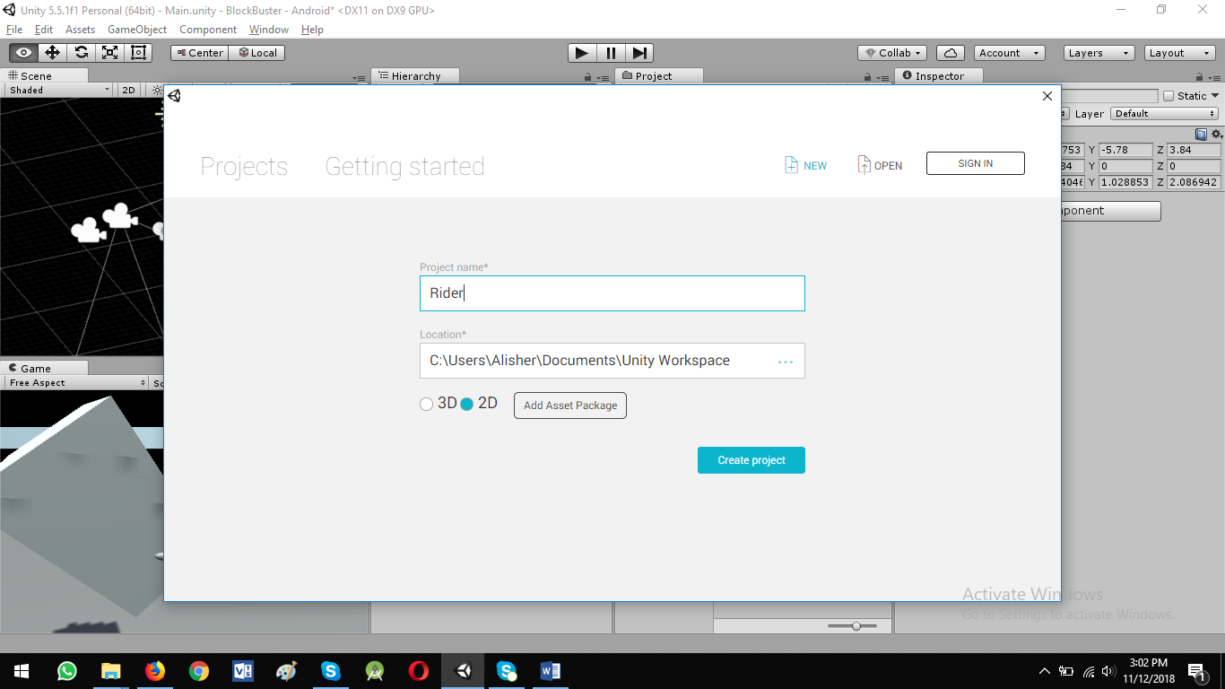

1. Make background of Main Camera: Dark

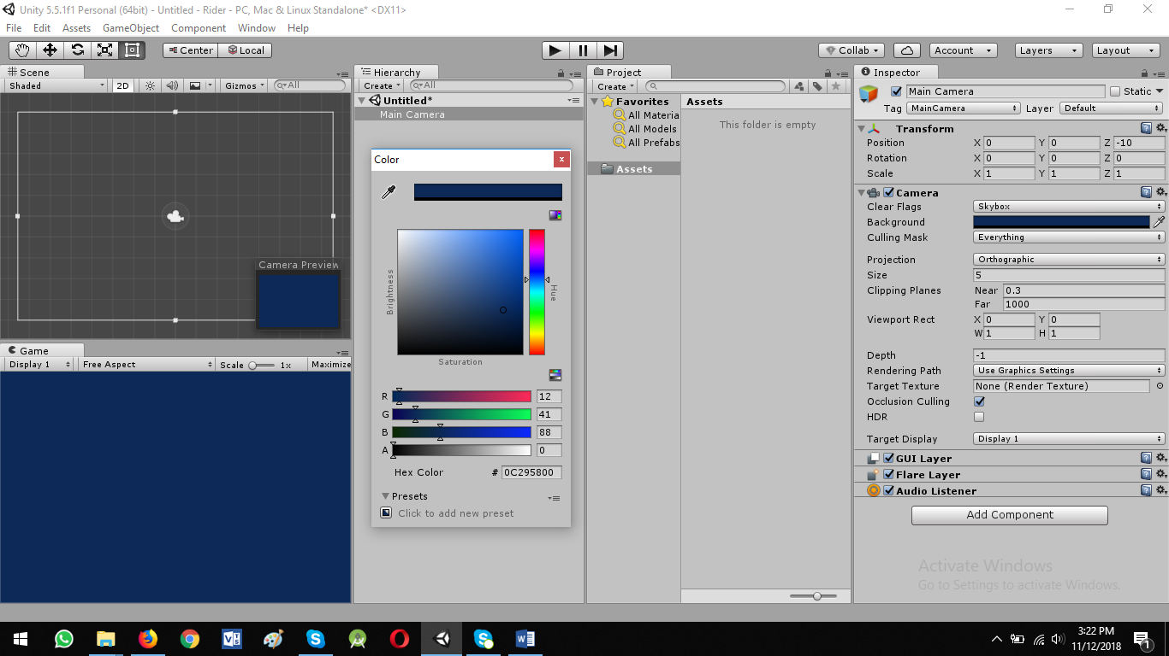

1. Save the Scenes

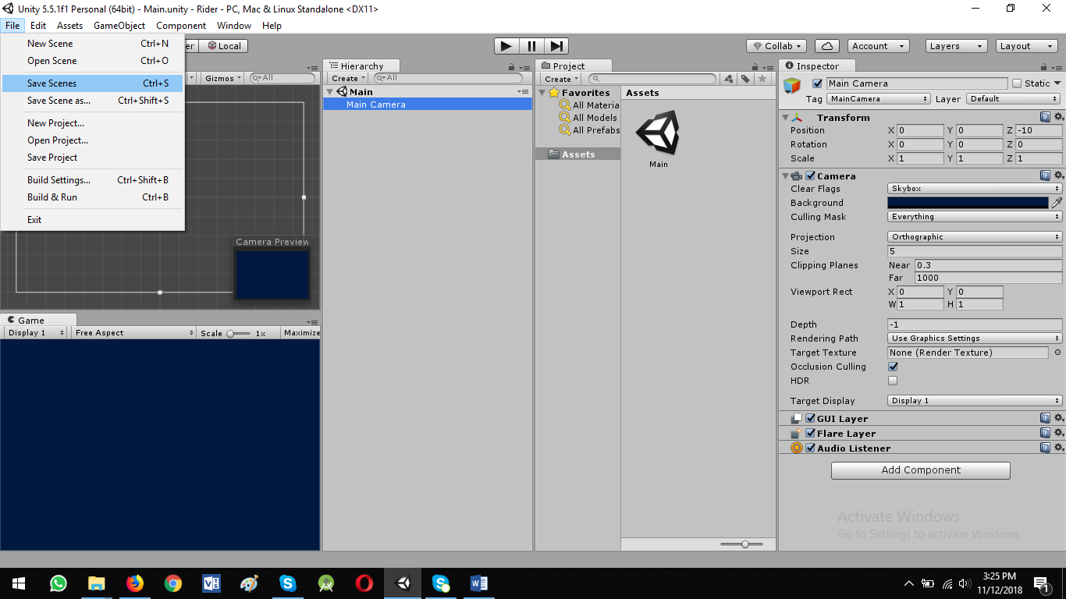

1. Make a tiny Sprite

* Right click in Hierarchy View -> 2D Object -> Sprite

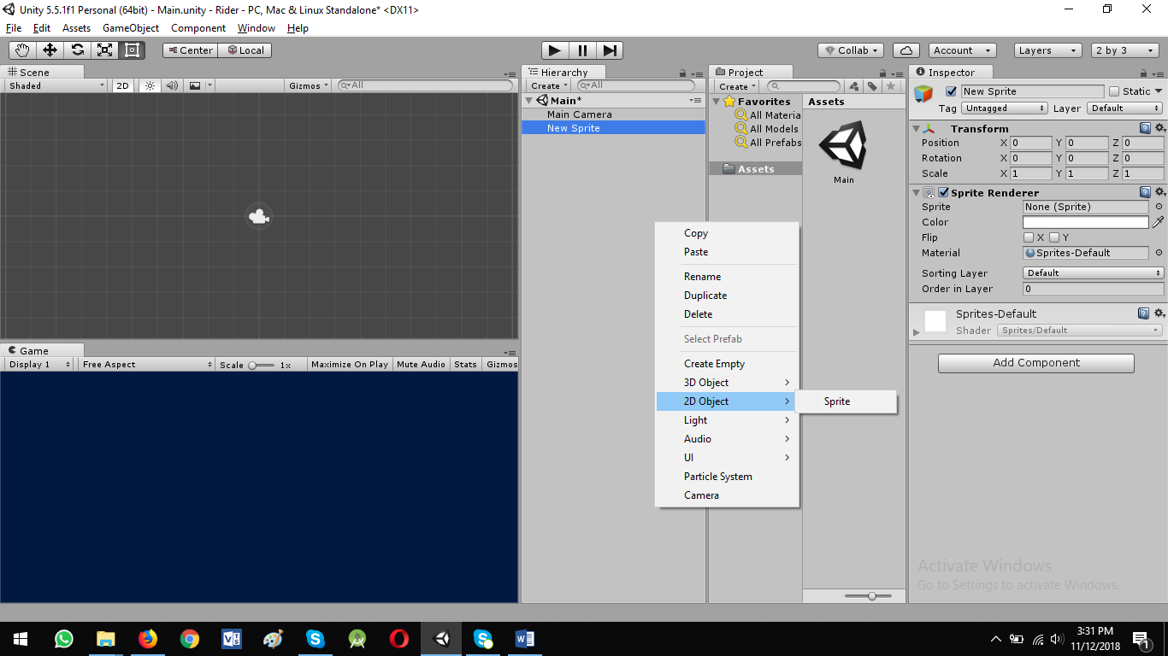

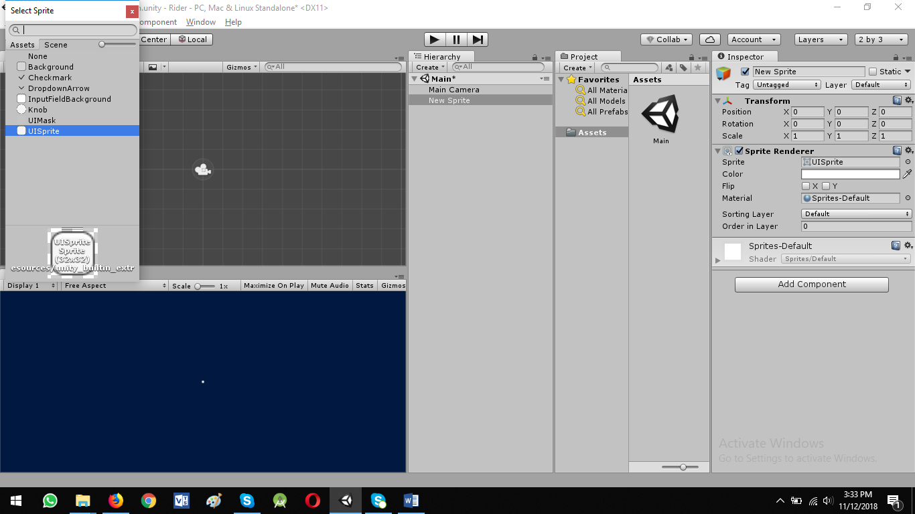

Scale: x = 5, y = 5

1. Go to Assets Store
   * Download Post Processing Stack
   * Import all assets

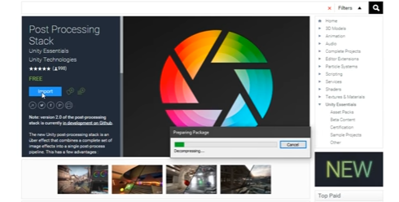

using MinAttribute = UnityEngine.PostProcessing.MinAttribute;